**Guideline for Identify All Relevant Topics Hitapp**

In this hitapp, you are given an article or reading material and some topics on the right. Your job is to identify relevant or interesting topics for follow-up.

**Note:** If the page **needs to Login** or **cannot Load** in a new tab, then please select the **Page Load Error** option.

Here are the criteria you **need to meet** when choosing topics. All of them:

**Relevance/Interestingness:**

You are looking for relevant or interesting follow-up topics in the context of the reading material you are given.

Imagine a person who finds the reading material on the left interesting. Look at the topics and choose the ones that are relevant or interesting standalone to explore and follow up.

**Note:** Topics that are too broad, like 'Movies' 'Romance' "News' shouldn't be considered relevant/interesting.

**Grammar and Spelling:**

All the topics should be **formatted grammatically** and should have the **correct spelling**. If a topic is incomplete or not spelled correctly, don’t select it as a relevant topic.

**Offensiveness:**

The topics you select **MUST NOT** be offensive to show to users.

NO explicit or adult meaning and intent.

NO racial, religious, gender, or other slurs and insults.

**Example 1:**

***Url:*** [Microsoft - Wikipedia](https://en.wikipedia.org/wiki/Microsoft)

|  |  |  |
| --- | --- | --- |
| ***Topic*** | ***Choice*** | ***Reason*** |
| Microsoft | SELECT | This topic is what the page focuses on. |
| Microsobt Windows | DO NOT SELECT | This topic is misspelled, should be Microsoft Windows. |
| Xbox | SELECT | This topic is relevant to the page. (Xbox is a video gaming brand owned by Microsoft) |
| Bill Gates | SELECT | This topic is relevant to the page. (Bill Gates is the founder of Microsoft) |
| Microsoft Stock Price | SELECT | This topic is relevant to the page. |

**Example 2:**

***Url:*** [All Tom Hanks movies - IMDb](https://www.imdb.com/list/ls067560129/)

|  |  |  |
| --- | --- | --- |
| ***Topic*** | ***Choice*** | ***Reason*** |
| Tom Hanks | SELECT | This topic is what the page focuses on, which is talking about Tom Hanks’ movies. |
| Movies | DO NOT SELECT | This topic is too general. If someone were to search this topic to learn more, they would probably find other movies not related to Tom Hanks. |
| Mazes and Monsters | SELECT | This topic is relevant to the page. “Mazes and Monsters” is one of Tom Hanks’ movies, it is relevant and useful. |
| Tom Hanks Latest Movie | SELECT | This topic is relevant to the page. Moreover, users may be interested and want to explore more. |
| All Tom Hanks | DO NOT SELECT | This topic is not grammatical and incomplete. It does not make sense. |

**Example 3:**

***Url:*** [Hulu Help - Hulu](https://help.hulu.com/s/)

|  |  |  |
| --- | --- | --- |
| ***Topic*** | ***Choice*** | ***Reason*** |
| Hulu | SELECT | This topic is what the page focuses on. |
| Hulu Video Quality Setting | SELECT | This topic is related to this page, and users may be interested and explore more. |
| App Download Hulu | SELECT | This topic is relevant to the page. Users may have the intent to explore more about it. |

**Example 4:**

***Url:*** [Mena VPN, UAE on App Store](https://apps.apple.com/us/app/mena-vpn/id1523850662)

|  |  |  |
| --- | --- | --- |
| ***Topic*** | ***Choice*** | ***Reason*** |
| Mena VPN | SELECT | This topic is what the page focuses on. |
| Personal VPN | SELECT | This topic is talking about VPN, and users may be interested and explore more. |
| iPhone | SELECT | The page is mainly talking about VPN for iPhone. iPhone is one of the most important entities mentioned on this page. |

**Example 5:**

***Url:*** [Solar panel maintenance guide: How to clean and repair solar panels (msn.com)](https://www.msn.com/en-us/news/technology/solar-panel-maintenance-your-guide-to-cleaning-and-repairing-solar-panels/ar-AAQjza1)

|  |  |  |
| --- | --- | --- |
| ***Topic*** | ***Choice*** | ***Reason*** |
| Solar Panel Cleaners | SELECT | This is a good follow-up topic. The user is clearly doing research. It is relevant to the article, spelled correctly, grammatical, and not offensive. |
| Panel Maintenance | DO NOTSELECT | If someone were to search with this topic to learn more, they will not find information on ‘solar panels’ only, but potentially other “panels”. |
| Rust Best Way to Place Solar Panels | DO NOTSELECT | This topic is not grammatical, therefore is not a good topic. |

**Example 6:**

***Url:*** <https://kahoot.it/answer/result>

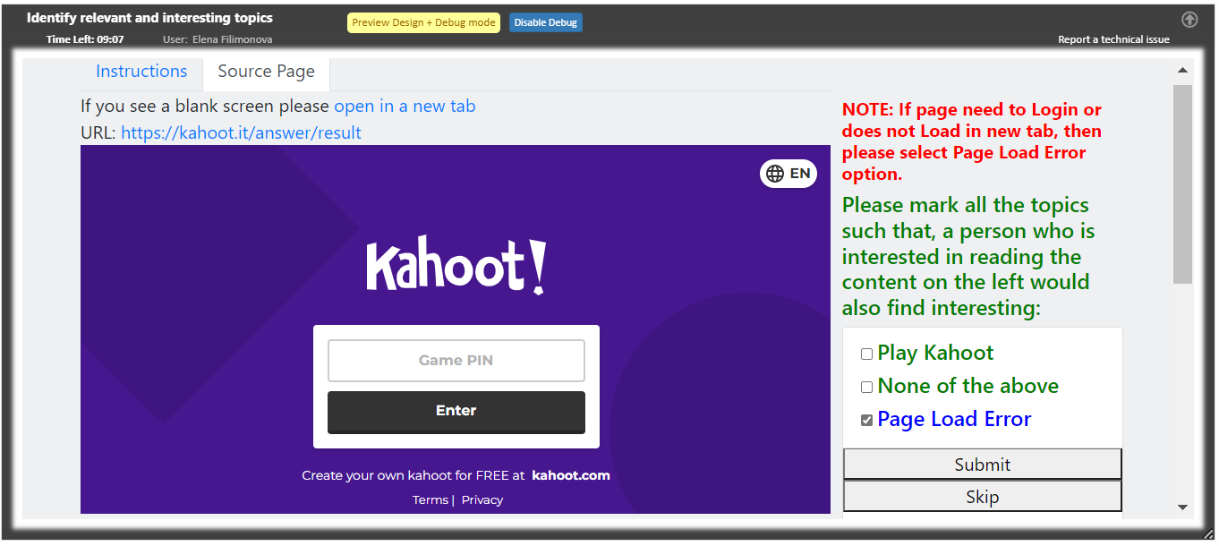

|  |  |  |
| --- | --- | --- |
| ***Topic*** | ***Choice*** | ***Reason*** |
| Play Kahoot | Page Load Error | The game PIN is needed. |

**Example 7:**

***Url:*** [Bank of America - Banking, Credit Cards, Loans and Merrill Investing](https://www.bankofamerica.com/?TYPE=33554433&REALMOID=06-000aea23-f082-1f06-b383-082c0a2840b5&GUID=&SMAUTHREASON=0&METHOD=GET&SMAGENTNAME=-SM-aqqfzgjeqy8S5m8u%2b8h6gZjIC5XifZeAeb5F64xMRkTo1mmai3SO2HDPyq%2bg0LdA&TARGET=-SM-HTTPS%3a%2f%2fsecure%2ebankofamerica%2ecom%2fcgi--bin%2fias%2fA%2f1%2fbofa%2fibd%2fIAS%2fpresentation%2fCEReturnEntryPoint%3fce_return_to%3d100)

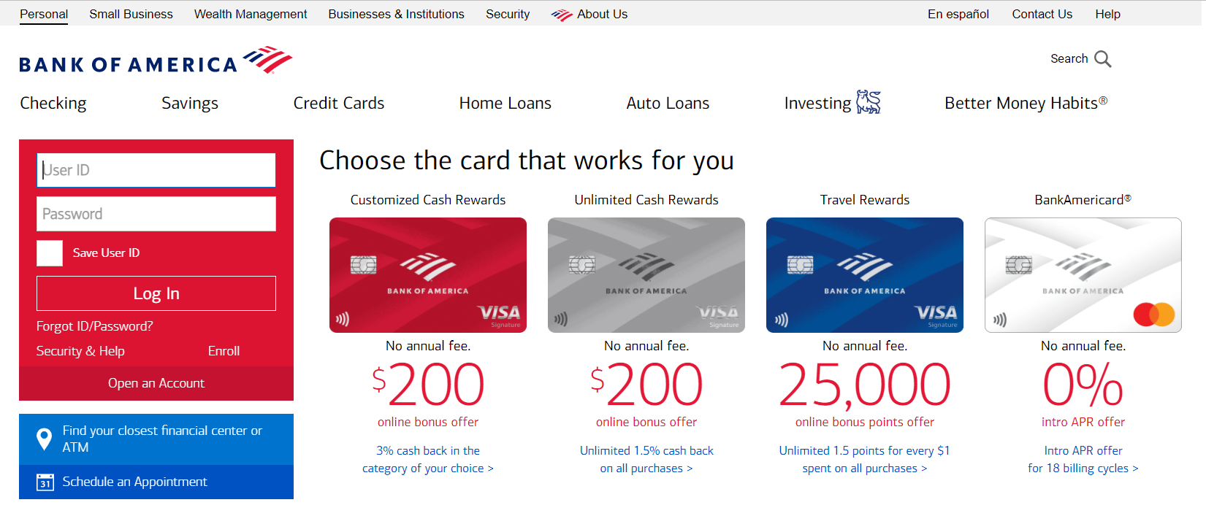

|  |  |  |
| --- | --- | --- |
| ***Topic*** | ***Choice*** | ***Reason*** |
| Bank of America | SELECT | The bank's web page contains information about the bank's products, although there is an authorization block for entering the Internet bank. |

**Example 8:**

***Url:*** <https://banking.westpac.com.au/secure/banking/securemessages/inbox>

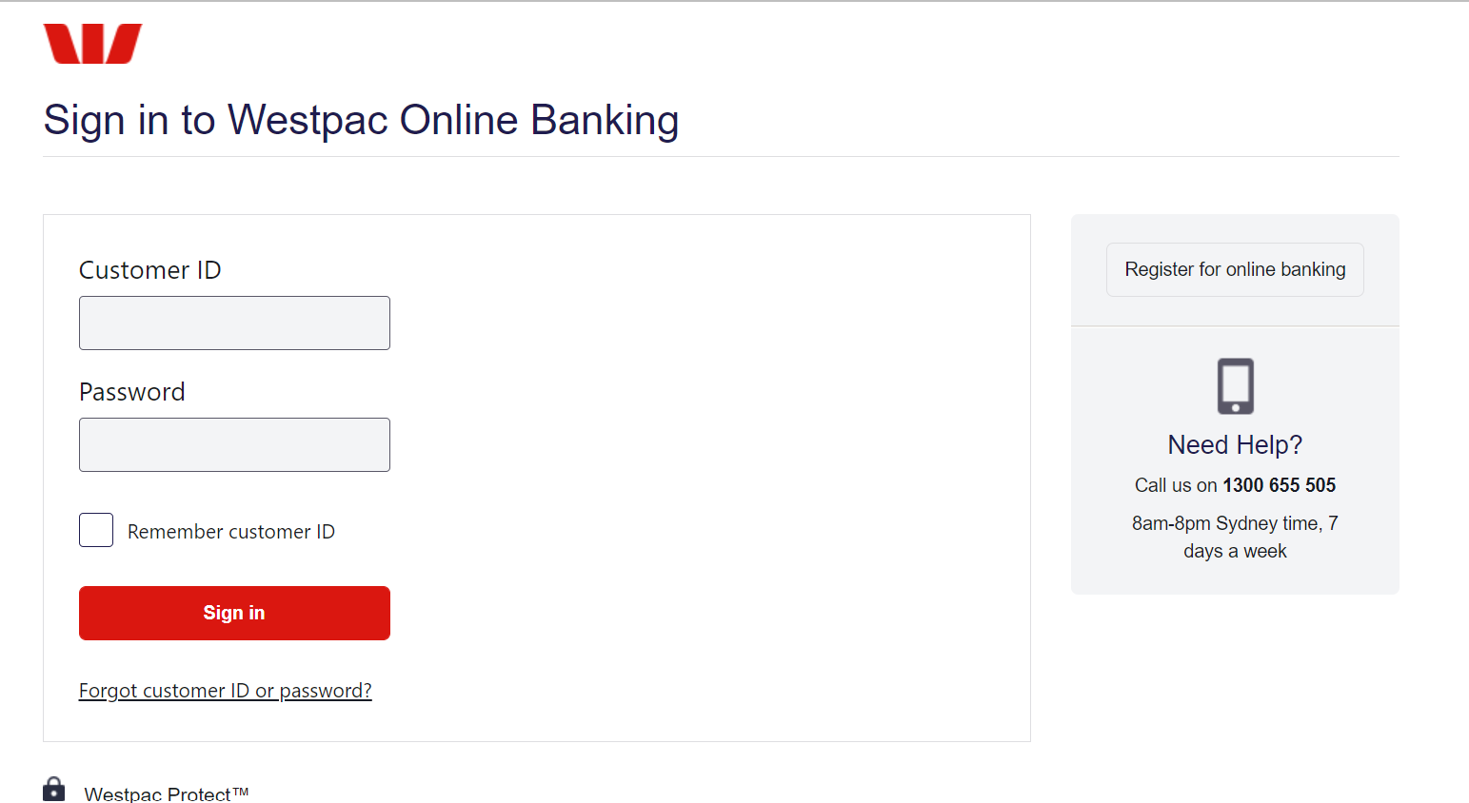

|  |  |  |
| --- | --- | --- |
| ***Topic*** | ***Choice*** | ***Reason*** |
| Westpac Online Banking | Page Load Error | The customer ID and password are needed. |